**Personal portfolio summary (release 1)**

I, John Zheng, a team member of TNT team (#42). I take the responsibility of database design and white box testing among our seven-people team. In our media vault project, release 1 is divided into two sprints. In sprint 1, I came up with some special ideas into user stories and help our team to split user stories into sprints by measuring story points. Meanwhile, I designed the databases for our project which is based on group discussions. In sprint 2, I kept modifying our databases and handling with some database problems when other team members made changes related to database. Also, some white box tests, as supports for system development, were done by myself.

There are five artefacts can be taken as the examples of my work as following:

1. **‘IFB299 Group42 user story.doc’**

In this document, the example stories for part of my work are listed, such as background color and music (#28/#29), recently documents (#27) and contact us & feedback (#26).

1. **‘User story points (design).xlsx’**

In this document, the evidences of measuring processes are still remained, like the figure showing below.

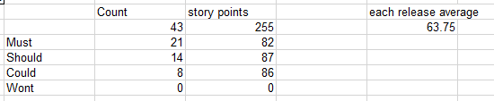

1. **‘Database document.doc’**

This document is the raw material for database design. Five tables in database with details can be definitely shown in this artefact.

1. **‘Database Schema Diagram (UML Diagram).accdb’**

This artefact is made for showing the relationships between tables by using UML models, which can be used to inform the technical design of the system and improve the user experience. The relationships are shown as below.

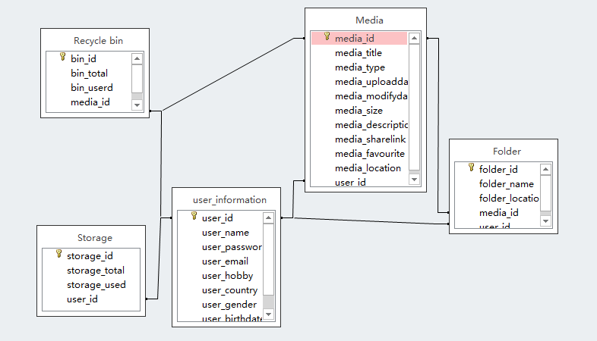

1. **‘MySQL for Creating Database.txt’**

This artefact records the source codes of creating five tables for media_vault database in MySQL.

These five items can be taken as examples of my work in release 1. However, my contributions are not limited to these. I have done my duties in peer review business letter and given some suggestions on UI design. Furthermore, all of us attended every week’s group meetings actively and formed into an effective workplace.

John Zheng

TNT Team (#42)

22/09/2015